The name of the invention: SOS Mini

**The problem that it solves:**

The problem our invention solves is the problem when someone is in trouble and they can’t contact anybody for help. This particularly happens with children who can get lost, kidnapped, or worse. Many many kids don’t have phones or other devices in which they can contact their parents in an emergency. Older people that have phones and forget stuff easily can use our device.

**Solution:**

What we have come up with is a complicated yet easily used wearable device. It will send a SOS signal to the phone it's programmed to plus the location of the person wearing the device. You can have it with you anywhere. It could be waterproof. Anyone can use it even those with memory loss because it's a very simple function. It’s not too big and easily portable. It won’t take up that much space. It will be made of a very smooth material that can fit on your arm so as to not damage your skin. It won’t be too tight if you have it on your arm or neck.

**How does it work?**

You turn on a switch and wave your hand in front of the sensor and the arduino that’s connected to the sensor will send a signal to your phone. The switch will be on the box that it comes with.

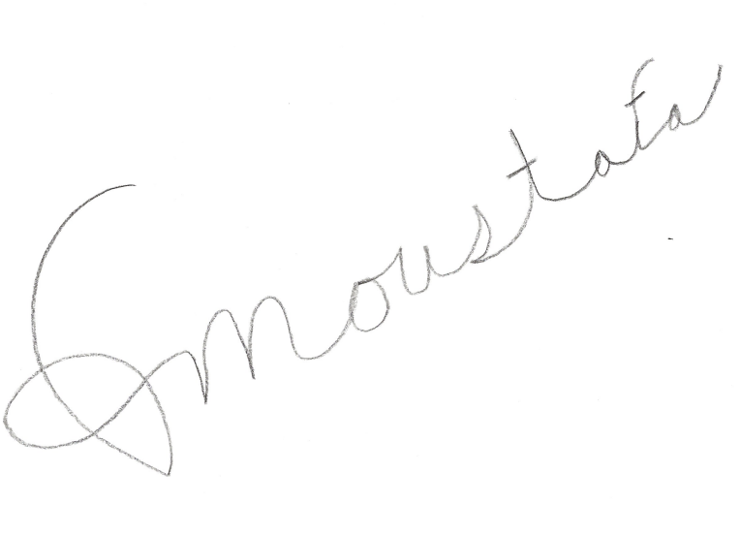



Signature(s):

Inventor Name(s):Sammer Moustafa and Khalid Al-Zawawi

Date: 2/15/2021

Grade: 5th Grade

School: Michigan Islamic Academy

Town: Ann Arbor and Brownstown

1. What problem are you trying to solve? The more specific you are in describing the problem, the better your solution will be. How did you come up with the problem?

The problem we are trying to solve is the problem of people being lost or endangered. We came up with the problem when we thought of people, kids, and elderly, all in danger of not being able to communicate with the people they trust or the authorities.

2. What is the result you are trying to achieve? The more specific you are in describing the result you want, the better your solution will be.

The Result we are trying to achieve is that people will be able to communicate with loved ones and get help when they are in danger. For example if you are lost and you are at a place where you know nobody and you will panic and not know what to do but if you have our invention you can communicate with parents and they will know your location and that you are in trouble.

3. What are some possible solutions? Which one did you choose to pursue? How did you decide which solution to try? The more specific you are in describing the solution you will create, the better your invention will be. How did you come up with the solution?

Some possible solutions are the cellphone, different SOS gadgets, mini siren. The idea we chose is a gadget box that is wearable waterproof and most of all simple to use and effective. The gadget box is a box with a button on top so when you press that button it sends a notification to anyone you want and it sends your location to a trustworthy person or the authorities. It is wearable with minimal radiation and is portable.

4. Has this solution been done before? If it exists, how is your approach different and better? What research did you do to see if this invention had been done before? Who did you talk to? Where did you look? What website did you search? You should show 4 pieces of evidence of different types of research – talking with experts, searching the internet, interviewing friends and family as to how useful this would be, etc. Where I looked to see if my idea is new:

We interviewed family and friends to see if they faced this problem. The results of our interview are in the table below:

|  |  |  |  |
| --- | --- | --- | --- |
| **Gender** | **Age** | **Have you ever been in the situation? Or have you seen it in the community?** | **Will our solution help you?** |
| M | 10 | YES | YES |
| M | 11 | YES | YES |
| F | 11 | Not been in the situation but seen it in the community. | YES |
| F | 8 | Not in the situation but slightly seen it in the community. | YES |
| F | 21 | Knows it happens but hasn’t ever seen it. | YES |
| F | 47 | Worried that her children would get lost and not be able to communicate with her. | Would feel a lot safer if their child had one. |
| M | 51 | Something that has potential to happen with kids but doesn’t remember it happening before. | Extremely agrees. |
| F | 17 | Has happened multiple times in the pas | YES |
| F | 15 | Has seen it in the community but hasn’t really happened before. | Will be very beneficial. |

We also looked at various sources for existing solutions. Here is where we looked:

A. Amazon B. Google C. Youtube D. Best Buy

Document any similar inventions you found, describing how yours will be different:

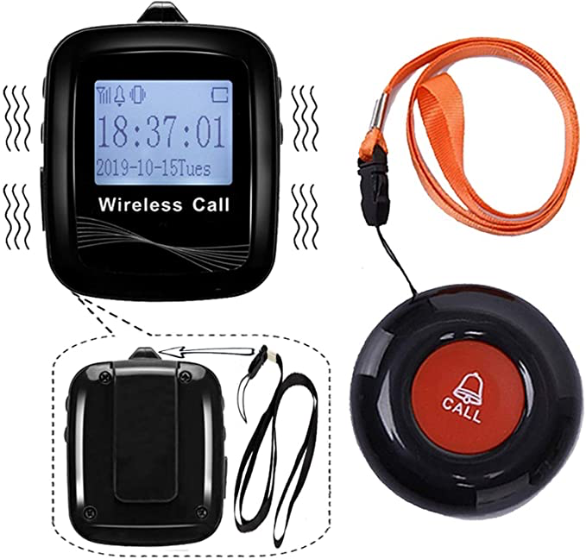

|  |  |  |  |
| --- | --- | --- | --- |
| (5 points Each) | Silent Beacon | Cellphone | CallToU |
| **Simple to use** | Yes | No | Yes |
| **Wearable** | Yes | No | Yes |
| **Waterproof** | No | No | No |
| **Camouflaged/ Indistinct** | No | No | No |
| **Not too big** | yes | Slightly | yes |
| **Portability** | yes | yes | yes |
| **Radiation Free** | Maybe | Yes |  |

# Our Invention will be

* Simple to use
* Wearable
* Waterproof
* Camouflaged/ Indistinct
* Not too big
* Portable
* Minimal Radiation

# 

Teacher Signature - REQUIRED FOR ALL PARTICIPANTS

I approve of the solution/invention my student has chosen to pursue and agree that it not only meets the guidelines shown on the Restrictions and Requirements nts page, but that it is also safe.

Teacher’s Name : **Beverly Qoronfleh**

Teacher’s Signature: 

Date: 2/26/2021

I approve of the solution/invention my student has chosen to pursue and agree that it not only meets the guidelines shown on the Restrictions and Requirements page, but that it is also safe.

5. Draw a model (a sketch or drawing) of the invention you are thinking about building. Label all the important parts and features. Explain how the invention will work. If you need more space, use another blank page.

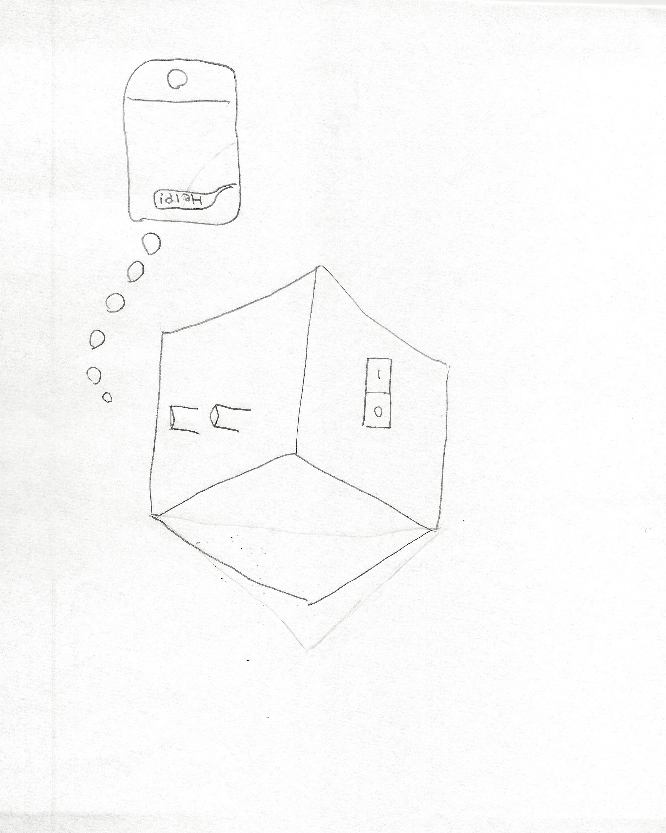

The Invention will work by pushing a button, and waving your hand in front of the sensor and zap! It will send a message to the phone it’s programmed to say “Help!”

6. What problems or issues might you encounter with this design? Is this design compatible with the principle of sustainability? Who did you talk to about this design (another student, parent, teacher, etc.)? What were their comments about your design?

The problems that we might encounter with this design are size, shape, making the box wearable, and camuflagibility. Also another problem is trying to tell the person where they are. The box is way too bulky and is completely not portable.

7. How can you fix those problems or address those issues?

We can shape the box the way everyone finds it easier to use. We can attach the box to a small wristband to make it portable and wearable.

8. Repeat steps 5 to 7 until you have a design that you think will work. You may have to make multiple copies of a blank page until you have a good design.

Version 2: Our second time, we made the box portable but was way too big. Also it failed to be camouflaged. We can fix it by using small electronic parts to make the box a lot smaller. Also we can design the outside of the box better so it looks nicer.



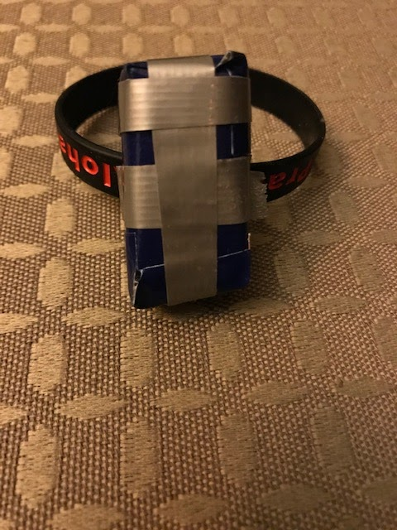

Version 3: Our final time was our best design. It was small, portable, and easy to use. More improvements can be made, but for now it is good.

9. What parts, materials will you need to make the invention and how much will they cost.

1. Wrist Bands: $5
2. Arduino MKR GSM 1400 : $68.90
3. PVC Casing : $10
4. Arduino Battery: $5
5. Cardboard:$2

10.Where will you get those parts and materials?

We will get these parts on amazon.

11. What additional skills or abilities will you need to make the invention?

We will need strength, experience, patience, craftsmanship, and teamwork.

12. Who can help you build the invention?

Dr. Muhaamad, Ms. Shiri Vivek, both professors at EMU can help us with our project.

13. Get the parts and materials and build the invention (with help).

Done

1. Test and evaluate the invention. What did you do to test the invention?

We tested the invention by asking our friends and family about the invention like if it is too big or too small

or if they have been in a situation where they will need our invention and if it will be useful for the community

1. Identify any problems with the invention. What will you change to make it better?

We will try to disguise it better. We will make it work without any flaws. We will work to change the material to something sturdier.

1. Repeat steps 5 to 15 until the invention works as planned. You may have to copy and make multiple copies of this blank page until you have an invention that works the way you want?

17. Naming your invention is important.

* + What words describe your invention?

Some words that describe our invention are:

1. Gadget
2. SOS
3. Device
4. Micro
5. Mini
6. Advanced
   * Think in terms of words that will help you name your invention.

I think a few words that might help me name our invention are micro, SOS, gadget, and quick. Also maybe the words electronic and mini might be used.

* + What is the function of your invention?

The function of our invention is to improve kids safety and to prevent terrible results of urgent emergencies like someone being kidnapped.

* + Think in terms of marketing it. How will it solve the problem? How will it help others?

It will solve the problem because once the child/elder activates the device, they can easily get help from parents or from a trusted person and the person will know where they are. It will help others know where the person who has the device is, and will know that they are in trouble.

* How is your invention different from others that may already be on the market? If it is similar, what did you do to make it better? How is it different?

On the market, the other products that are similar are way too high of a price. Also it is mostly for older people and not kids. It is not th

* + Who is your target audience? Who would use your invention?

Our target audience will be mainly elederly, children, handicap people, mentally ill people, and even regular people can use it to build safety. It really all depends on who needs it and won’t be counted as a liability to them.

Some creative attention-getting techniques you can use are:

* Alliteration (using the same first letters or sounds): “Kit Kat”
* Rhyming: “Light Bright”
* Alternative spelling: “Sno Bal”
* Using numbers in the name: “Super Clean 3000”
* Describing the function of the invention: “Hydro-Blast”
* Based on this analysis, what are some good names for your invention?
* The Micro Dynamo
* The SOS Mini
* The Mini SOS Gadget
* Which name do you like best and why?

We like The SOS Mini because it is community attractive and the name is really catchy. Also it describes our project perfectly.

18: Create your display board. This is an example of what a Display Board might look like, but you can make it look however you want. This is your invention and your display, so use your creativity to tell the story of your invention the way you want.

Done

19. Be prepared to answer questions. Here are some questions that you might be asked in the Judging Circle by the judges or fellow students. To help you prepare, you might want to write down some of the important parts of your answers so that you have them when you practice giving your presentation.

• How did you come up with the idea for this invention?

We came up with the idea of this invention when we thought of safety for children and that sometimes kids don’t have a simple portable and easy to use way to contact help.

• What people, situations, or conditions does this problem affect?

This problem affects children, elderly, and other people with special needs.

• How did you come up with your solution to the problem?

We came up with it when we looked up a lot of problems in the city and state and most of them were about people not able to contact loved ones to tell them important stuff or if they were endangered and didn't have a phone with them to contact authorities or people they trust.

• Where did you get the materials for the invention?

We got the materials from amazon and walmart.

Who helped you build the invention and what did they help you do?

Ms Shiri Vivek and Dr Mouhamad Ahmad helped us build the prototype and they helped us with the log book and the video pitch.

• Are there other, better materials you could have used that would improve the invention?

Yes, I think there are other and better materials we could use for the invention.

• Who has used your invention and what did they think about it?

Some of the people experienced the wearable gadget that we made and gave us feedback about its size and appearance but because we didn't finish the final prototype, we do not have their feedback on the overall invention and how it works.

• What changes might you want to make to your invention?

We want to turn it into a working prototype after the event.

**Done !**